CHAPTER 4

Lesson Plan

This chapter can be covered in one longer class period or two shorter class periods.

LESSON FOCUS
This chapter is to introduce the concept of survey research in order for students to gain an understanding of common survey components, question sequencing, scales and response options, development mistakes to avoid, survey distribution methods, online survey software, response rate, and respondent privacy.

LEARNING OBJECTIVES
- Determine when to use and how to properly design business research surveys
- Articulate the use of common survey components
- Create surveys that employ best practices in survey development
- Identify and avoid common survey development mistakes

The Survey — Overview
Surveys are primarily quantitative instruments made up of mostly closed-ended questions. Researchers aggregate closed-ended responses to calculate quantitative data, such as mean scores and percentages.

Surveys can have qualitative components. Open-ended questions are the qualitative components of a survey. Open-ended questions are developed to gather in-depth responses and to give context to quantitative results.

Discuss with students how surveys are mostly closed-ended. It would be too taxing to respondents and labor intensive to researchers to have a survey include mostly open-ended responses.

Surveys are usually based on a sample.

- Sampling refers to collecting data from and studying a subset of a population.

Researchers must strive to create an instrument that is clear and concise and that measures what it is purported to measure.

Impart the saying “garbage in, garbage out” to students. This strongly applies to survey research. Incorrect or poor quality survey design will always produce a flawed output.

Survey Components
Start with the objective. Researchers need to ask themselves how results from each question will be used to help address the research objective. If it is unclear how responses from a question will help address the overarching objective, the question should not be included.

Convey to students that not only will responses to extraneous questions be unhelpful, question deletions are often sought since researchers fight to keep survey length to a minimum.

INCLUDE COMMON UNIVERSAL SURVEY COMPONENTS
- Overall measures
- Demographic questions
Overall Measures
- Overall measures are high-level questions in which results can be expressed as a single mean score or percentage. They gauge the overall sentiment regarding the subject being evaluated and are used for tracking results over time (trending) as well as for correlation analysis.

Explain correlation analysis: Correlation analysis can be used to look for relationships between results from overall measures and other data on the survey. Such analysis can be used to gauge how strong of an impact individual survey items have on overall indicator. Knowing the strength in these relationships can be useful when recommending where to focus efforts.

Demographic Questions
Demographic questions are used to describe sample representation and to segment results.

Demographic questions commonly gather information about the following:
- Age
- Education level
- Employment status
- Ethnicity
- Gender
- Geography
- Household income
- Housing (such as rent, own, condo, house)
- Marital status

Explain to students that if demographic sample data differs too greatly from the target population of study, the survey will not be representative. Segmenting results can help marketers communicate more optimally with different segments or even help guide development of products specifically designed for certain segments. But demographic questions should not be included on the survey unless there is a plan to use them. Too many demographic questions can be annoying to the respondent.

Question Sequencing
Screener questions are questions placed before the core survey questions in order to determine if a potential respondent qualifies to take the survey.

Explain how a screener may be necessary if a sample list doesn’t contain the detail needed to determine if a potential respondent is qualified to take the survey (i.e., is a member of the target market).

Branching questions are questions placed before a sequence of questions and that only apply to a subset of respondents. Most survey software allows for branching based on prior responses.

Demographic question placement: Unless they are being used as screener questions, demographic questions should go at the end of the survey. Demographic questions tend to be more personal in nature and could be jarring if they come first in the sequence.

Demographic questions are not crucial to report overall results, which is another reason they are left to the end of the survey. If the respondent quits the survey before answering the demographic questions, the survey can typically still be used in analysis.

Survey Length
The length of time a respondent will devote to a survey is linked to:
1) the survey format (telephone, mail, online, mobile)
2) the importance of the topic to respondents

Most surveys should take no more than 5-7 minutes to complete. Long surveys risk incomplete responses and termination by the respondent.

Ask students which formats they think can get away with longer surveys and which demand the survey be short. Ask students which topics might allow for longer surveys (those in which the respondent has a vested interest). Discuss “micro-surveys” students may have seen online that ask only one question.

Scales and Response Options
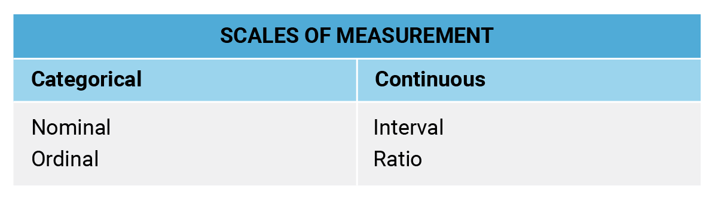
Figure 4.5.1
- Categorical measurements have values that can be counted as part of distinct groups.
  - A nominal measurement has two or more categories, but there is no natural order to the categories.
  - An ordinal measurement has two or more categories that can be placed in a clear order.

- Continuous measurements use values that can be expressed numerically and placed in a logical order.
  - An interval scale of measurement has a clear order and also displays the exact difference in values along the scale.
  - Like an interval measure, ratio scales have an equal distance between each data point. The difference is there is an absolute “zero point” that is treated as the point of origin.
Make students aware that even though the concept of scales of measurement is being introduced as a part of the survey design section, they also apply to data collected from other sources, such as internal or external databases.

- Likert scales are survey responses that offer a range of options from one extreme to another.
Likert scales may include a neutral midpoint. Likert scales that display the numbers along the scale are referred to as “anchored Likert scales.”

EXAMPLE
– Very satisfied
– Somewhat satisfied
– Neither satisfied nor dissatisfied
– Somewhat dissatisfied
– Very dissatisfied

Use the same scale for meaningful comparisons. When gathering ratings on items / features / competitors, use the same scale for meaningful comparisons.

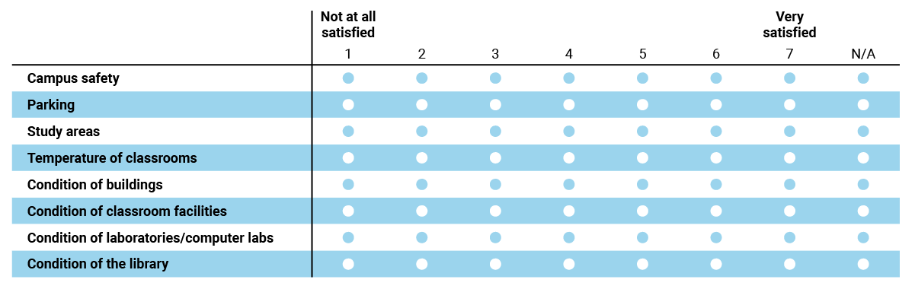

Figure 4.5.2

This way of displaying a question that uses the same scale while rating several different features of dimensions is often referred to as a “matrix question.”

Use a logical order for most response options. Categorical response options do not have a logical order. Therefore, it may make sense to randomize options so that different respondents see them in a different order to avoid order bias.

Response Option Randomization Example

How did you hear about our service (select all that apply)? [Respondent A]
  - Billboard
  - TV ad
  - Radio ad
  - Internet ad
  - Newspaper ad
  - Poster
  - Mailing
  - City bus ad

How did you hear about our service (select all that apply)? [Respondent B]
  - Poster
  - Billboard
  - Internet ad
  - TV ad
  - Newspaper ad
  - Mailing
  - City bus ad
  - Radio ad

Ask students to imagine if “Billboard” were always the first option in the lists above. Because it is the first item respondents see, it would likely result in more respondents selecting the option, giving it an erroneous inflated score. Randomization can be easily employed in electronic surveys.

Include “Not Applicable” where necessary. Researchers shouldn’t force respondents to rate items they are not familiar with.

Avoid overlapping response options. Options should be mutually exclusive in order for respondents to make appropriate choices.

Open-ended questions are commonly used to 1) gather strengths and weaknesses of a concept or experience; 2) collect top-of-mind thoughts (such as unaided awareness in a brand perception study); and 3) act as a catch-all for collecting items the research team may not have thought of (such as asking what other features are important in a new product development survey).

Ask students to think of open-ended questions they’ve answered on a survey recently. How was the question phrased to assure responses would be open-ended and not simple yes / no answers?

Development Mistakes to Avoid
- Complex questions: Questions with multiple components and / or stipulations
- Leading questions: Slanted to imply preference to a particular response, thus biasing the result
- Loaded questions: Suggest respondents give a socially desirable answer.
- Ambiguous questions: Questions that are too vague, causing respondents to interpret the meaning on their own
- Double-barreled questions: Two questions in one; can usually be recognized by the inclusion of “and” in the statement or by lists of several items
Ask students for examples of each and discuss how such errors can damage results. This chart can be found in the text with examples included if needed.

Survey Invitations
The survey invitation should generally be no more than 4-5 sentences and include the following components:
- Researcher’s credentials (company or research firm collecting responses)
- The purpose of the survey
- Reason respondent is being asked to participate (i.e., what makes him or her qualified)
- How responses will be used
- If responses will be kept confidential or anonymous
- Survey due date
- Incentive (if applicable)

Inform students that since the information in the invitation is often separated from the survey, duplicating the information at the top of the survey as an introduction is a good practice.

Survey Reminders
To increase the response rate to surveys, it is typical to send one or two “reminder” messages. Reminders are stripped down versions of full invitations that are meant to encourage non-respondents to complete the survey. It is good practice not to contact potential respondents with more than two reminders.

Survey Distribution Methods

Online
Best Uses and Benefits:
- Brief to average-length surveys
- Suitable for surveys with some level of complexity due to survey software’s ability to incorporate skipping questions and randomization
- Surveys that require reaction to images and video clips
- Offers respondents a level of comfort and confidentiality, which can help foster truthful responses

Not Good For:
- Surveys where potential respondents have no affiliation with study sponsor or when study sponsor is kept blind; email invite deletion rates are high if respondent doesn’t feel the survey is applicable
- Surveys that require clarification of responses or detailed explanation of concepts
- Populations without access to technology or who have technology aversion (although this is becoming more and more rare)

Snail Mail
Best Uses and Benefits:
- Brief surveys with some moderate levels of complexity; good for surveys requiring time and thought when recording responses
- Targeting specific geographies
- For sensitive study topics where anonymity is important; as long as no identifiers are coded onto survey linking results back to individuals (a practice with some mail studies), respondents can be assured their responses will not be linked to their identities

Not Good For:
- Long surveys requiring multiple sheets of paper or excessive writing
- Complex surveys that require skip logic, randomization, or multiple versions; while using multiple versions of a paper survey is possible, handling them can be complex for researchers
- Projects requiring a quick turnaround
- Surveys that require the clarification of responses or explanation of concepts

Telephone Interview
Best Uses and Benefits:
- Moderate length surveys, around 7-10 minutes; respondents may become agitated and hang up
- Surveys for which respondents need to be screened to qualify as members of the sample
- Surveys that benefit from a guided approach an interviewer can provide
- Business research that requires getting past gatekeepers to interview the appropriate respondent

Not Good For:
- Random studies of the general population; landlines are no longer
the norm and cell phone numbers are not published, although sample lists may be purchased in which respondents have provided their mobile numbers with permission
- Sensitive studies where talking to an individual may alter respondent behavior

Ask students for examples of survey topics that would best fit each of these distribution methods.

Online Survey Software
There are many online survey software programs available. Three of the most used are SurveyMonkey, Qualtrics, and Google Forms.

Discuss which survey software you plan on using in the course (if any). Discuss students’ experiences with these or other survey software tools. What are the pros and cons?

The Response Rate
The response rate is the percentage of those who complete the survey out of those invited to take the survey. Response rates are typically included in a study’s methodology section.

Inform students that with response rates, the higher the percentage the better. There will always be potential respondents who will not respond to or complete a survey for a variety of reasons. Response rates are almost never 100%.

FACTORS IMPACTING RESPONSE RATES
- Distribution method (mail, online, telephone, etc.)
- Incentives offered
- Potential respondents’ interest or investment in survey topic
- Survey length
- Survey complexity
- Type of audience a survey is attempting to reach (consumer or industry; internal to a company or external)
- Whether the study is blind or the sponsor is disclosed

Many factors influence a survey’s response rate. Ask students which of these items have influenced their willingness to participate in a survey the most.

Protecting Respondent Privacy
- Confidentiality refers to not sharing individual responses with anyone outside of the research team, including the study sponsor.
- Anonymity refers to data in which even the researcher cannot identify respondents. Respondents in this case are anonymous.

Discuss the differences between confidentiality and anonymity. Talk about how anonymity is the stronger of the two since researchers cannot even identify respondents using this type of collection.

